My Edits
Welcome to your little slice of ePublisher Express Trial. This is your “My Edits” section. In this section, you will be able to add your content and then see it in the generated output. By now you should have a little bit of an idea of how ePublisher works. The trial is generating output from pre-built stationery synchronized to the ePublisher Express Trial project.
This document and the others have been imported to the Express project and appear in the Documents window. When you press the generation button, ePublisher opens each document and reads the information contained within. ePublisher will never change the source documents, it reads them for the content and the style names. We have customized the stationary to these source documents. Once you purchase a seat of ePublisher, you will be able to customize a project to your styles. This process is a detail in ePublisher Designer. For now, have some fun with the styles and space below we have provided for you. We left everything pretty simple, so feel free to use some of the skills you just learned in the previous document. You can create related topics, expand/collapse sections, or add some mini-TOCs. Remember to edit in this document, and use the style names provided. Once done, just save the file and publish with one click to see the results.

Put your links here
Link to PDF -
Link to WebPage – http://www.webworks.com/

How to Create Dummy Text in Word
If you are interested in Lorem ipsum and how to generate it in Word, here is a little tip. There are a few commands in Word that will automatically generate content for you. The formula is “=<type of text>(# of Paragraphs, # of sentences in the paragraphs). Below are the types of text you can get Word to generate for you.
- Enter the command “=rand(1,2)” for text in the style of help information. This is helpful if you want something that approximates English text.
- Enter the command “=lorem(1,2)” for text in classic lorem ipsum format. This is used if you are looking for page space value and content is not important
- Enter the command “=rand.old(1,2)” for some nostalgic versions of the quick brown fox pangram. Click for more information on The quick brown fox jumps over the lazy dog.

Examples of Types of Text
First, I hope you take note of the font color in the above heading. Make sure to take a look at the generated output. ePublisher ALWAYS generates blocks of content the exact way you specify. We want all our titles and headings to be uniformed in the output regardless of how they appear in the source document.
Now we can get to the examples. In the first example, we entered “=rand(4,7)”. In the second example, we entered “=lorem(2,5). In the final example, we entered “=rand.old(3,8)”

Type Text rand “=rand(#,#)” Example
Video provides a powerful way to help you prove your point. When you click Online Video, you can paste the embed code for the video you want to add. You can also type a keyword to search online for the video that best fits your document. To make your document look professionally produced, Word provides header, footer, cover page, and text box designs that complement each other. For example, you can add a matching cover page, header, and sidebar. Click Insert and then choose the elements you want from the different galleries. Themes and styles also help keep your document coordinated.
When you click Design and choose a new Theme, the pictures, charts, and SmartArt graphics change to match your new theme. When you apply styles, your headings change to match the new theme. Save time in Word with new buttons that show up where you need them. To change the way a picture fits in your document, click it and a button for layout options appears next to it. When you work on a table, click where you want to add a row or a column, and then click the plus sign. Reading is easier, too, in the new Reading view. You can collapse parts of the document and focus on the text you want.
If you need to stop reading before you reach the end, Word remembers where you left off - even on another device. Video provides a powerful way to help you prove your point. When you click Online Video, you can paste the embed code for the video you want to add. You can also type a keyword to search online for the video that best fits your document. To make your document look professionally produced, Word provides header, footer, cover page, and text box designs that complement each other. For example, you can add a matching cover page, header, and sidebar. Click Insert and then choose the elements you want from the different galleries.
Themes and styles also help keep your document coordinated. When you click Design and choose a new Theme, the pictures, charts, and SmartArt graphics change to match your new theme. When you apply styles, your headings change to match the new theme. Save time in Word with new buttons that show up where you need them. To change the way a picture fits in your document, click it and a button for layout options appears next to it. When you work on a table, click where you want to add a row or a column, and then click the plus sign. Reading is easier, too, in the new Reading view.

Type Text lorem “=lorem(#,#) Example
Lorem ipsum dolor sit amet, consectetuer adipiscing elit. Maecenas porttitor congue massa. Fusce posuere, magna sed pulvinar ultricies, purus lectus malesuada libero, sit amet commodo magna eros quis urna. Nunc viverra imperdiet enim. Fusce est.
Vivamus a tellus. Pellentesque habitant morbi tristique senectus et netus et malesuada fames ac turpis egestas. Proin pharetra nonummy pede. Mauris et orci. Aenean nec lorem.

Type Text rand.old “=rand.old(#,#) Example
The quick brown fox jumps over the lazy dog. The quick brown fox jumps over the lazy dog. The quick brown fox jumps over the lazy dog. The quick brown fox jumps over the lazy dog. The quick brown fox jumps over the lazy dog. The quick brown fox jumps over the lazy dog. The quick brown fox jumps over the lazy dog. The quick brown fox jumps over the lazy dog.
The quick brown fox jumps over the lazy dog.The quick brown fox jumps over the lazy dog.The quick brown fox jumps over the lazy dog.The quick brown fox jumps over the lazy dog.The quick brown fox jumps over the lazy dog.The quick brown fox jumps over the lazy dog.The quick brown fox jumps over the lazy dog.The quick brown fox jumps over the lazy dog.
The quick brown fox jumps over the lazy dog.The quick brown fox jumps over the lazy dog.The quick brown fox jumps over the lazy dog.The quick brown fox jumps over the lazy dog.The quick brown fox jumps over the lazy dog.The quick brown fox jumps over the lazy dog.The quick brown fox jumps over the lazy dog.The quick brown fox jumps over the lazy dog.

Try Adding Some Pictures or Links to Videos
This section is for you to add your multimedia assets to get a feel for how they work with ePublisher. ePublisher allows you to handle this in some ways. For now, we recommend just using the native functions of your authoring tool to add your media assets inline. You will see them appear in the output in the same manner.
When you have a full seat of ePublisher, you will be able to change some of the asset behaviors in the generated output, but for now, you can see how easy it is to add multimedia to your outputs.

Inserting an Image Into a Word Document Natively
From a file, you can insert an image using the Insert tab.
- Pick the location where you want the image by placing your cursor at the insertion point.
- With the cursor in place, select the Insert tab on the menu bar, and click the Pictures command
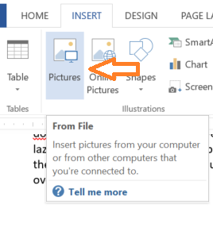

- A new window will open titled “Insert Picture” Use this interface to select the picture you would like, and click insert.
- The image will appear in the document
- Resize the image using the sizing handles. You will see that however you size the image will be reflected in the published output.

Inserting a Video in to a Word Document

With ePublisher you are not stuck with just text and a hyperlink to your videos:
Click for Video
ePublisher will transfer any valid link during the generation process. If you want to add videos to your output, just use the native ability of Word to insert your video.
The video below is on Youtube. To insert it, I placed the cursor in the area I wanted to insert the video. I then click the menu item “Insert,” and then click Online Video. This opened a second window:

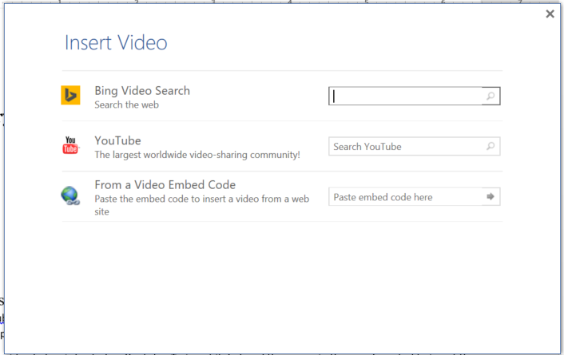
This window is used to help word create a link to your video. For example below, we used the YouTube search option. In the search bar, I put the title of the video in “” to narrow down the search results. Then I selected the correct video and clicked next to have Word place a thumbnail in the document.

Positioning Your Video in a Word document

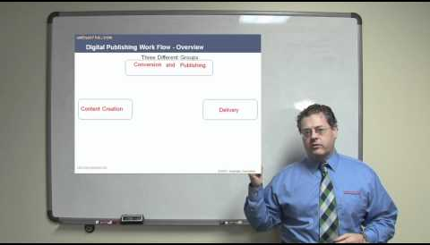
Now that I had my thumbnail, I just needed to position it. First, I picked the wrapping. For this thumbnail, I went with tight. Next, I selected the thumbnail image and clicked on the format menu to bring up formatting options.

If you do not see the formatting options, be sure to left click on the word “format.” With the formatting options, I was able to crop, resize and position the image as I wanted. Once done, I can save the document, and now it is ready for publishing.

Even More Control Over Your Media
If you do not like the native media import ability of your authoring tool, ePublisher allows you to put HTML code directly in your source documents and pass through on generation. With this technique, ePublisher will integrate your HTML code into the final output page.
In this example, when Word embeds a video, it launches the video in another window when played. I would like a different result. I want the video to play on the output’s open page. To do this, I am going to use the pass-through function of ePublisher. Here is the code I want to be integrated into to my output page:
<iframe width="560" height="315" src="https://www.youtube.com/embed/D4QoQWboM-U" frameborder="0" allow="autoplay; encrypted-media" allowfullscreen></iframe>

(Might be a good place for a related topic….hint….hint)
If you are unsure how to get the embedded code from Youtube, here are the steps (might
- Find the video you would like on Youtube.
- Click on the share button
- In the second window, click on the embed button
- Copy the code.
Do you remember how to get to the Word ADD-INS menu? We have provided a way for you to use conditions in Word. If you open that tab, you will see the WebWorks Menu. (Note, be sure to enable your content in Word to use the menu). By clicking on the conditions {} tab, I open the conditions window.

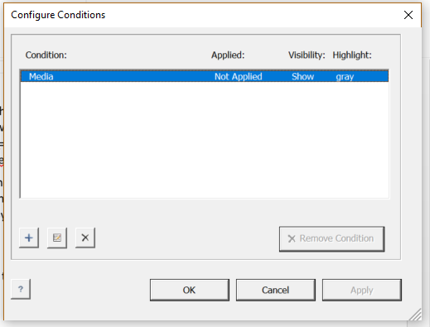
Now I am going to highlight the code and apply the Media condition to the highlighted area. The background turns gray to mark the area and show the condition was applied.

<iframe width="560" height="315" src="https://www.youtube.com/embed/D4QoQWboM-U" frameborder="0" allow="autoplay; encrypted-media" allowfullscreen></iframe>
The highlighted area is also the exact location where the video will be in the output. With this powerful feature of ePublisher, it is that simple to control media in your output and with the pass-through feature; you can take full advantage of the properties of HTML5.

Place a link to a PDF here –
Please a link to a WebPage here -

